Table of Contents

Tesseract using LSTM 1

Reading Other Languages 2

Holt-Winters Forecast Method 3

A Single Holt-Winters Exponentially Smoothed Model 4

Double Holt-Winters Exponential Smoothing (HWES2) 5

Triple Holt-Winters Exponential Smoothing (HWES3) 6

Forecasting with Holt-Winters Exponential Smoothing (Triple ES) 7

Building a Chatbot 9

## Tesseract using LSTM

Tesseract is an open source text recognition (OCR) Engine, available under the Apache 2.0 license. Tesseract uses a Long-Short-Term Memory model. Tesseract can be used to read and extract text from an image.

This section is based on content from:

<https://www.linkedin.com/pulse/open-source-ocr-using-tesseract-google-colab-suyesha-bhattacharjee>

Example : PyTesseract

This example shows how to implement PyTesseract to read text from this image.



In Google Colab run this install:

|  |
| --- |
| !sudo apt install tesseract-ocr |

Then run this install:

|  |
| --- |
| !pip install pytesseract |

Next, the following imports are needed. Run the code and perform any module installs if required.

|  |
| --- |
| import pytesseract  import shutil  import os  import random  try:  from PIL import Image  except ImportError:  import Image |

Upload an image to the Google Colab folder. Name it image.png. I have had better results with png so this format is recommended. Once the image is uploaded, this code should extract the text from the image and print the text.

|  |
| --- |
| image_path_in_colab='./image.png'  extractedInformation = pytesseract.image_to_string(Image.open(image_path_in_colab))  print(extractedInformation)  print("done") |

Success! Tesseract was able to extract the text.

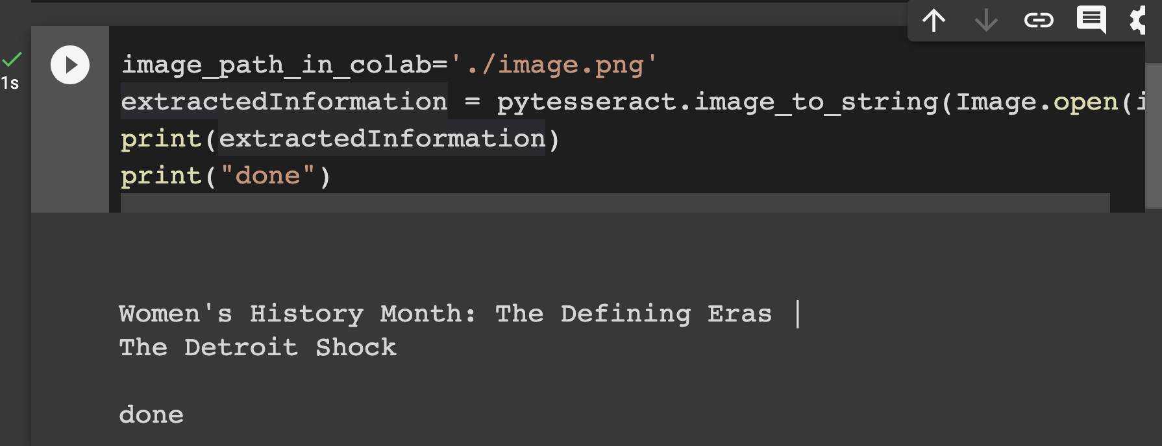

Exercise (4 marks)

Create a png image with a graphic and your printed name with a normal font in it. Show your image here:

|  |
| --- |
|  |

Take a screenshot of your notebook output in Google Colab. The screenshot must show the code and the text output that is successfully read by Tesseract:

|  |
| --- |
|  |

## Reading Other Languages

Tesseract can read many languages. See:

<https://tesseract-ocr.github.io/tessdoc/Data-Files-in-different-versions.html>

Example : Reading Korean and English

This example will read a png image with Korean and English it. This is the image:



|  |
| --- |
| !sudo apt install tesseract-ocr-kor |

Here is the code:

|  |
| --- |
| import pytesseract  import shutil  import os  import random  try:  from PIL import Image  except ImportError:  import Image  image_path_in_colab='adobe.png'  print(pytesseract.image_to_string(Image.open(image_path_in_colab), lang='kor+eng'))  print("Done") |

It works! Note, I did try another image where Tesseract failed. If that happens, try experimenting with different image formats.



## Holt-Winters Forecast Method

The Holt-Winters Forecast method provides a exponentially smoothed time series model that is based on a combination of raw data, trend and seasonality. This tutorial is based on the article at:

<https://medium.com/analytics-vidhya/python-code-on-holt-winters-forecasting-3843808a9873>

Example : Time Series Decompisition

This first example shows how to break a model down into the different components like we have done before. The example uses the AirPassenger.csv dataset.

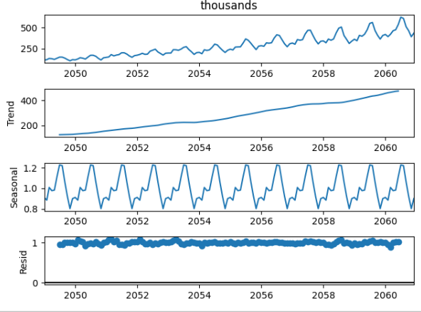

|  |
| --- |
| # dataframe opertations - pandas  import pandas as pd  # plotting data - matplotlib  from matplotlib import pyplot as plt  # time series - statsmodels  # Seasonality decomposition  from statsmodels.tsa.seasonal import seasonal_decompose  # holt winters  # single exponential smoothing  from statsmodels.tsa.holtwinters import SimpleExpSmoothing  # double and triple exponential smoothing  from statsmodels.tsa.holtwinters import ExponentialSmoothing  path = '/Users/pm/Downloads/AirPassengers.csv  airline = pd.read_csv(path, index_col='date', parse_dates=True)  # finding shape of the dataframe  print(airline.shape)  # having a look at the data  print(airline.head())  # plotting the original data  airline[['value']].plot(title='Passengers Data')  decompose_result = seasonal_decompose(airline['value'],model='multiplicative')  decompose_result.plot()  plt.show() |

### A Single Holt-Winters Exponentially Smoothed Model

Exponentially smoothed models can be created with the SimpleExpSmoothing class.

SimpleExpSmoothing(airline['value']).fit(smoothing_level=alpha, optimized=False, use_brute=True).fittedvalues

Example : Single Exponential Smoothing

To begin, a single exponentially smoothed model will be created with the AirPassenger.csv data. To do this, a weight coefficient Alpha and a Time Period at the monthly level must be chosen. As expected, the model didn’t fit well because Single ES doesn’t work for data with Trends and Seasonality.

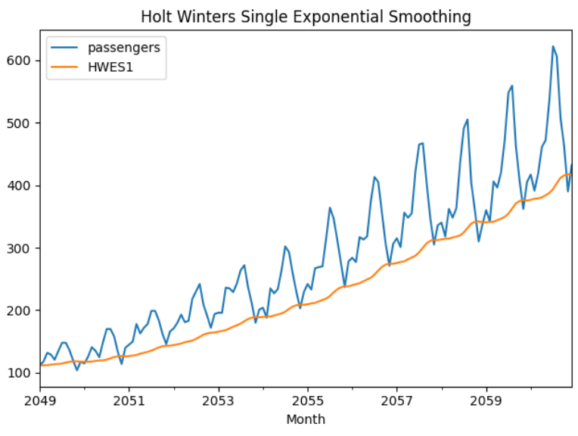

Here is the code that builds the SimpleExpSmoothing model with a month start, ‘MS’ frequency.

|  |
| --- |
| # Set the frequency of the date time index as Monthly start as indicated by the data  airline.index.freq = 'MS'  # Set the value of Alpha and define m (Time Period)  m = 12  alpha = 1/(2*m)  airline['HWES1'] = SimpleExpSmoothing(airline['value']).fit(smoothing_level=alpha, optimized=False,use_brute=True).fittedvalues  airline[['value','HWES1']].plot(title='Holt Winters Single Exponential Smoothing');  plt.show() |

### Double Holt-Winters Exponential Smoothing (HWES2)

In an effort to improve over Example 4, the exponentially smoothed model is fit with raw data and trend data. This particular model uses a trend that is obtained with an additive trend.

airline['HWES2_ADD'] = ExponentialSmoothing(airline['value'],trend='add').fit().fittedvalues

Example : Double Holt-Winters Exponential Smoothing

This example shows how to implement double Holt-Winters exponential smoothing with raw and trend data. In this example, two separate HWES2 models are built. The first HWES2 model is built using additive decomposition and the second model is built using multiplicative decomposition.

Figure : Comparing raw passenger data with HWES2 additive and HWES2 multiplicative models.

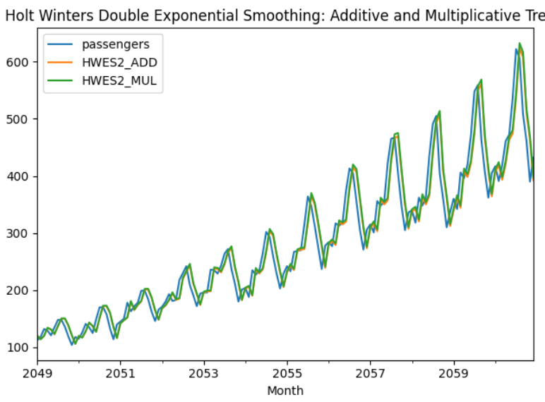

Here is the code which implements both HWES2 models. To build this example, add this code onto Example 4.

|  |
| --- |
| # HWES2 model fit with raw and additive trend data.  airline['HWES2_ADD'] = ExponentialSmoothing(airline['value'],trend='add').fit().fittedvalues  # HWES2 model fit with raw and multiplicative trend data.  airline['HWES2_MUL'] = ExponentialSmoothing(airline['value'],trend='mul').fit().fittedvalues  # Plot raw data as well as fitted values for both HWES2 models.  airline[['value','HWES2_ADD','HWES2_MUL']].plot(title=\  'Holt Winters Double Exponential Smoothing: Additive and Multiplicative Trend')  plt.show() |

### Triple Holt-Winters Exponential Smoothing (HWES3)

Triple Holt-Winters Exponential Smoothing adds seasonality to the model in addition to raw smoothed data and trend data.

Example : Triple Holt-Winters Exponential Smoothing HWES3

The fit from HWES3 that is shown in Figure 2 looks better than the other models.

airline['HWES3_ADD'] = ExponentialSmoothing(airline['value'],

trend = 'add',

seasonal = 'add', seasonal_periods=12).fit().fittedvalues

Figure : Results from Triple Holt-Winters Exponential Smoothing

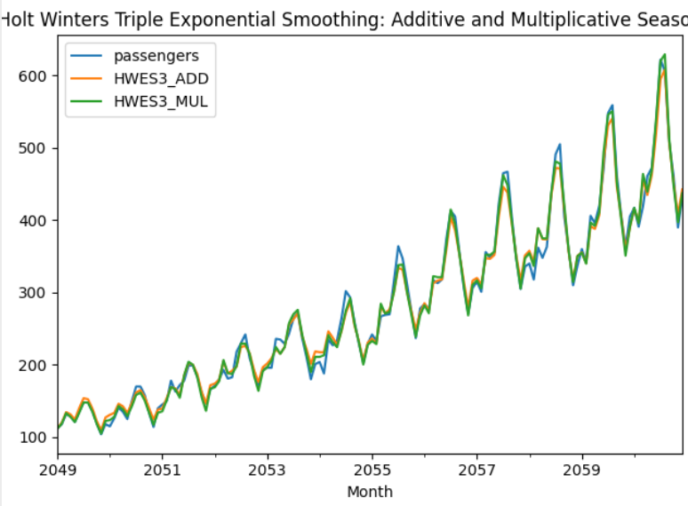

|  |
| --- |
| # HWES3 model fit with smoothed raw, additive trend, and additive seasonal data.  airline['HWES3_ADD'] = ExponentialSmoothing(airline['value'],  trend='add',seasonal='add',seasonal_periods=12).fit().fittedvalues  # HWES3 model fit with smoothed raw, multiplicative trend, and multiplicative  # seasonal data.  airline['HWES3_MUL'] = ExponentialSmoothing(airline['value'],  trend='mul',seasonal='mul',seasonal_periods=12).fit().fittedvalues  # Plot raw data as well as fitted values for both HWES3 models.  airline[['value','HWES3_ADD','HWES3_MUL']].plot(title=\'Holt Winters Triple Exponential Smoothing: Additive and Multiplicative Seasonality')  plt.show() |

### Forecasting with Holt-Winters Exponential Smoothing (Triple ES)

The real benefit of Holt-Winters Exponential Smoothing models is that they enable decent predictions. The green lines in Figure 3 shows the predicted output from the models.

Figure : Making Predictions with HWES3 Models

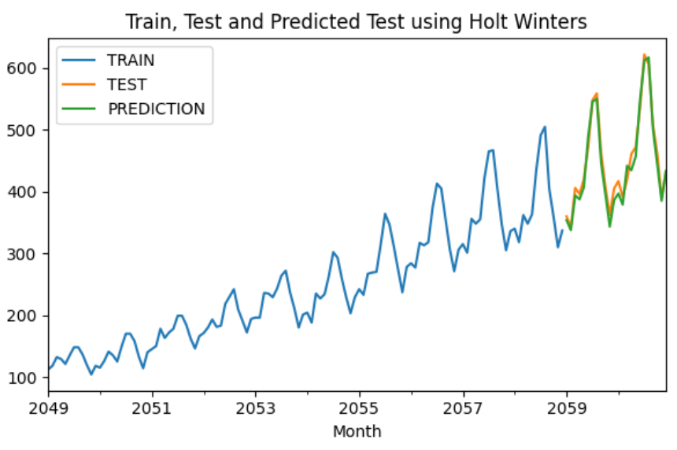

Example : Making Predictions with HWES3 Models

This example demonstrates how to use HWES3 models to generate the predictions that are displayed in Figure 3. The data is split into 120 data points for training and the last 24 data points for test.

|  |
| --- |
| import pandas as pd  from matplotlib import pyplot as plt  from statsmodels.tsa.holtwinters import ExponentialSmoothing  path = '/Users/pm/Downloads/AirPassengers.csv'  forecast_data = pd.read_csv(path,index_col='date', parse_dates=True)  forecast_data.index.freq = 'MS'  # Split into train and test set.  train_airline = forecast_data[:120]  test_airline = forecast_data[120:]  # Build HWES3 model with multiplicative decomposition.  fitted_model = ExponentialSmoothing(train_airline['value'],  trend='mul',seasonal='mul',seasonal_periods=12).fit()  test_predictions = fitted_model.forecast(24)  # Plot raw train, test and predictions.  train_airline['value'].plot(legend=True,label='TRAIN')  test_airline['value'].plot(legend=True,label='TEST',figsize=(6,4))  test_predictions.plot(legend=True,label='PREDICTION')  plt.title('Train, Test and Predicted Test using Holt Winters')  plt.show()  # Show RMSE.  from sklearn.metrics import mean_squared_error  import numpy as np  mse = mean_squared_error(test_airline,test_predictions)  rmse = np.sqrt(mse)  print('RMSE: ' + str(rmse)) |

Exercise (9 marks)

Using the **DailyDelhiClimateTest.csv** file, perform seasonal decomposition for **meantemp**. Show the graph of the output here:

|  |
| --- |
|  |

Next, build a double Holt-Winters Exponential Smoothed model. Use a daily frequency of data. Show the plot of predictions over 24 days here:

|  |
| --- |
|  |

Finally build a triple Holt-Winters Exponential Smoothed model. Use 12 seasonal periods. Show the plot of predictions over 24 days here:

|  |
| --- |
|  |

## Building a Chatbot

This section discusses the steps needed to build a chat bot. The discussion is based very closely on this series by Tech with Tim. His videos are excellent if you want a walk-through.

<https://www.techwithtim.net/tutorials/ai-chatbot/part-1/>

Example : Fitting a Chatbot Model

This example shows how to train a chat bot which answers frequently asked questions. I built my chat bot in Google Colab.

First, create an intents.json file. This intents.json file contains six different intents which contain:

* Tags (categories)
* Patterns (typical questions within a category)
* Responses (suitable answers to questions within a category)

Create this intents.json file and upload it to your Google Colab directory. You can run it locally if you prefer.

**intents.json**

|  |
| --- |
| {"intents": [  {"tag": "greeting",  "patterns": ["Hi", "How are you", "Is anyone there?", "Hello", "Good day"],  "responses": ["Hello, thanks for visiting", "Good to see you again", "Hi there, how can I help?"],  "context_set": ""  },  {"tag": "goodbye",  "patterns": ["Bye", "See you later", "Goodbye"],  "responses": ["See you later, thanks for visiting", "Have a nice day", "Bye! Come back again soon."]  },  {"tag": "thanks",  "patterns": ["Thanks", "Thank you", "That's helpful"],  "responses": ["Happy to help!", "Any time!", "My pleasure"]  },  {"tag": "hours",  "patterns": ["What hours are you open?", "What are your hours?", "When are you open?" ],  "responses": ["We're open every day 9am-9pm", "Our hours are 9am-9pm every day"]  },  {"tag": "payments",  "patterns": ["Do you take credit cards?", "Do you accept Mastercard?", "Are you cash only?" ],  "responses": ["We accept VISA, Mastercard and AMEX", "We accept most major credit cards"]  },  {"tag": "opentoday",  "patterns": ["Are you open today?", "When do you open today?", "What are your hours today?"],  "responses": ["We're open every day from 9am-9pm", "Our hours are 9am-9pm every day"]  }  ]  } |

This code converts the tags, patterns and responses to a stemmed vocabularity which is then vectorized for numeric representation. A deep neural net is then fit with the data. The data and the model are saved in separate binary files. Details about how the code works are in the comments.

|  |
| --- |
| import nltk  nltk.download('punkt')  from nltk.stem.lancaster import LancasterStemmer  stemmer = LancasterStemmer()  import pickle  import numpy  import tflearn  import tensorflow  import random  import json  with open('intents.json') as file:  data = json.load(file)  words = []  labels = []  docs_x = []  docs_y = []  for intent in data['intents']:  for pattern in intent['patterns']:  # Create word arrays.  wrds = nltk.word_tokenize(pattern)  # Add to vocabulary.  words.extend(wrds)  # Create x & y where x is the words of a sentence  # and y is the tag.  docs_x.append(wrds)  docs_y.append(intent["tag"])  # Add unique tag to labels.  if intent['tag'] not in labels:  labels.append(intent['tag'])  # Truncate words to reduce vocabulary.  # happen, happens and happening might be truncated to happen or some variation.  words = [stemmer.stem(w.lower()) for w in words if w != "?"]  # Get unique words.  words = sorted(list(set(words)))  labels = sorted(labels)  training = []  output = []  out_empty = [0 for _ in range(len(labels))]  # Create one-hot encoded vectors to represent words in the patterns.  # [1,0,0,1,0] etc.  for x, doc in enumerate(docs_x):  bag = []# Create bag of words containing all words for a pattern.  wrds = [stemmer.stem(w.lower()) for w in doc]  for w in words:  if w in wrds:  bag.append(1)  else:  bag.append(0)  # Store one-hot encoded tag associated with current bag of words.  output_row = out_empty[:]  output_row[labels.index(docs_y[x])] = 1  # Add bag of 1-hot encoded words and 1-hot encoded tag to separate lists.  training.append(bag)  output.append(output_row) # Assign tag for corresponding 1-hot-encoded vectors.  # Convert data to arrays.  training = numpy.array(training)  output = numpy.array(output)  # Save data.  with open("data.pickle", "wb") as f:  pickle.dump((words, labels, training, output), f)  from tensorflow.python.framework import ops  ops.reset_default_graph()  # Define network. (Each input is same size so training[0] same size as all samples.)  net = tflearn.input_data(shape=[None, len(training[0])])  net = tflearn.fully_connected(net, 8)  net = tflearn.fully_connected(net, 8)  net = tflearn.fully_connected(net, len(output[0]), activation="softmax")  net = tflearn.regression(net)  model = tflearn.DNN(net) # Create deep neural network.  model.fit(training, output, n_epoch=1000, batch_size=8, show_metric=True)  model.save("model.tflearn") # Save the model as a binary file. |

The diagram by Tim in Figure 4 represents the network created in Example 8. The diagram shows an input vector of an unknown length with two fully connected layers that are 8 neurons each. The softmax activation in the output layer assigns probabilities to the different tag labels.

Figure : Deep Neural Network Diagram Representing the ANN from Example 8.

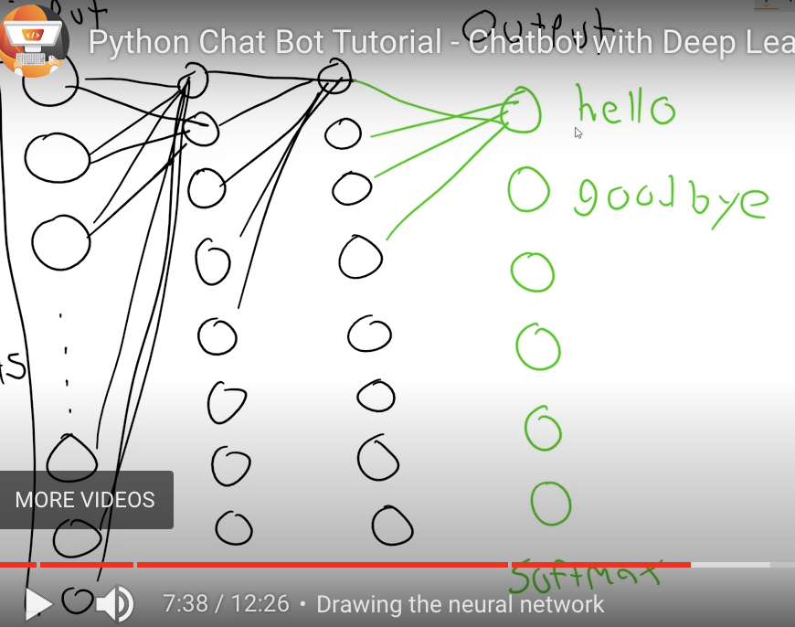

Example : Running the Chatbot Model

Once the model is fit, it is possible to run the chat bot with the following code. The chat bot is not great but with more data it can easily be improved.

|  |
| --- |
| # load data and model.  with open("data.pickle", "rb") as f:  words, labels, training, output = pickle.load(f)  model.load("model.tflearn")  # Convert sentence to 1-hot encoded vector that can be input into the model.  def bag_of_words(s, words):  bag = [0 for _ in range(len(words))]  s_words = nltk.word_tokenize(s)  s_words = [stemmer.stem(word.lower()) for word in s_words]  for se in s_words:  for i, w in enumerate(words):  if w == se:  bag[i] = 1    return numpy.array(bag)  # Prompt the user to ask a question and respond with an appropriate answer.  def chat():  print("Start talking with the bot (type quit to stop)!")  while True:  userinput = input("Ask a question: ")  if userinput.lower() == "quit":  break  results = model.predict([bag_of_words(userinput, words)])  results_index = numpy.argmax(results)  tag = labels[results_index]  for tg in data["intents"]:  if tg['tag'] == tag:  responses = tg['responses']  print(random.choice(responses))  chat() |

The chatbot was not great. It only answered one of my questions properly. With more data though it could easily be improved.

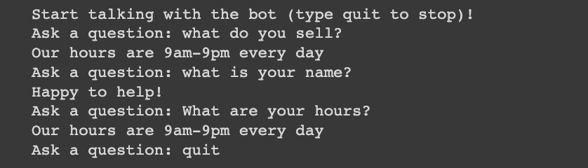

Exercise (4 marks)

Modify the intents.json file to include a new intent labelled with the tag “identification”. Handle the questions “What do you like to be called?”, “What is your name?”, “Who is this?”, “Who are you?”, and “Are you a real person?” Provide several answers that include your name.

Show the new intent here.Show your entry here:

|  |
| --- |
|  |

Train the model using Example 8 and the modified intent file with your name in the new intent. Then run Example 9. Take a screenshot of the question and response and show the screenshot here:

|  |
| --- |
|  |